Express Menu
901-730-1817
Drop off Delivery Only Minimum 12 Guests
Express Package #1 Express Package #2
Fresh Garden Salad Fresh Garden Salad Nacho Dorito Baked Chicken Chicken Broccoli Rice Casserole Fresh Steamed Broccoli Sauteed Yellow Squash Oven Roasted Potatoes Rolls/Butter Rolls/Butter …………..$11.00 per person $9.00 per person
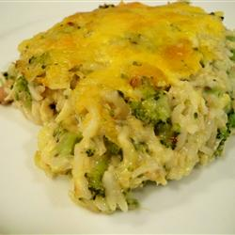
Express Package #3 Express Package #4
Fresh Garden Salad Fresh Garden Salad Ranch House Chicken Spaghetti Baked Italian Pork Chops Steamed Green Beans Mashed Potatoes Garlic Bread Fresh Cut Corn Rolls/Butter . . . . . $9.50 per person $10.00 per person
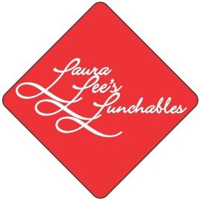
Ask About our Red Velvet Cupcakes, Chocolate Dipped Strawberries,,,
Prices do not include tax or delivery charges

